mini.mu Glove

Left Hand (Operate with right hand)
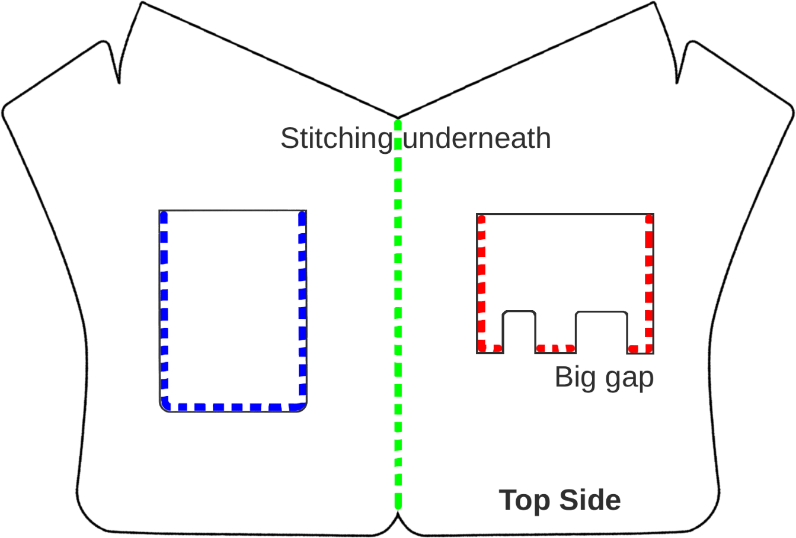

Right Hand(Operate with left hand)
